OBJECTIVE:

To inspect the property of creep in metals (lead in this experiment).

APPARATUS:

GUNT-Creep machine: is designed so that students may observe creep phenomena during a normal laboratory class using specimens.

SPECIMENS:

Three specimens which made of lead

THEORY:
When a material like steel is plastically deformed at ambient temperatures its strength is increased due to work hardening. This work hardening effectively prevents any further deformation from taking place if the stress remains approximately constant. Annealing the deformed steel at an elevated temperature removes the work hardening and restores the steel to its original condition. However, if the steel is plastically deformed at an elevated temperature, then both work hardening and annealing take place simultaneously. A consequence of this is that steel under a constant stress at an elevated temperature will continuously deform with time, that is, it is said to "creep".
Creep in steel is important only at elevated temperatures. In general, creep becomes significant at temperatures above about 0.4Tm where Tm is the absolute melting temperature. However, materials having low melting temperatures will exhibit creep at ambient temperatures. Good examples are lead and various types of plastic. For example, lead has a melting temperature of 326°C (599K) and at 20°C (293K, or about 0.5Tm) it exhibits similar creep characteristics to those of iron at 650°C.
Creep may occur under: Static tension, Compression, Bending, Torsion and Shear stress. Creep is a function of: stress, time and temperature. A metal is more likely to creep at higher stress level or after a long period of time even if the temperature is not elevated. Creep strength is defined as (the highest stress that a material can stand for specified time without excessive deformation). The creep rupture strength “Rupture strength" is defined as (The highest stress a material can stand for a specified time without rupture).
The SM106 Creep Measurement Apparatus is a simple unit designed for demonstrating and investigating the creep characteristics of lead and polypropylene specimens at room temperature. A temperature module is provided to enable investigation of the effects of temperature on creep rate.
Creep in metals:
A creep test is carried out by applying a constant load to a specimen and observing the increase in strain (or extension) with time. A typical extension - time curve is shown in Fig. 1.
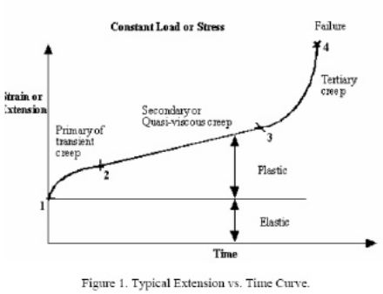
Three regions can be readily identified on the curve:

1 to 2 Primary Creep -creep proceeds at a diminishing rate due to work hardening of the metal.

2 to 3 Secondary Creep - creep proceeds at a constant rate because a balance is achieved between the work hardening and annealing (thermal softening) processes.

3 to 4 Tertiary Creep - the creep rate increases due to necking of the specimen and the associated increase in local stress. Failure occurs at point 4

Creep in plastics:
Plastics also creep at ambient temperatures but, compared to lead, they are able to sustain much greater extensions before failure, the creep curves are similar in shape to those for metals, but the mechanism of deformation is quite different because of the difference in structure of the material. A polymer consists of long chain-like molecules in a tangled and coiled arrangement; creep occurs by chains untangling and slipping relative to one another. The creep rate is still dependent on stress and temperature but equation 1 can no longer be applied.
The complex processes taking place during creep make it difficult to quote an equation that describes the creep behavior of all polymers. Many empirical equations have been proposed and one, which applies to some of the common engineering plastics, has the form
where ε is the tensile creep strain after a time t, σ is the applied creep stress, εο is the instantaneous or initial strain produced on loading, and Β, m, k are constants for a given polymer. The elastic component of the initial strain can be calculated by dividing the creep stress by the tensile modulus of the polymer, which for polypropylene is 1250 N/mm2. In many polymers this initial strain is very small and can be ignored, so that in these cases
Finally, it should be noted that with polymer materials the primary creep stage, where the creep rate is decreasing, is largely recovered when the creep load is removed. This behavior is unlike that observed in most metallic systems, and the effect can be easily demonstrated using the SM106 apparatus by removing the load after the polymer has been creeping for 20 to 30 minutes and continuing to take strain readings. It will be found that the elastic strain is removed instantaneously, but that further recovery of strain takes place over a period of several minutes. This time dependent effect is due to recovery of the viscoelastic component of the creep strain. For the stress levels used in the SM106 apparatus (typically 19 N/mm2), approximately 40% of the creep strain is recovered after 5 minutes.
Equations:
1) Actual deflection: D=D (t) +D₀.
Where “D₀” is the deflection at zero time
And “D (t)” the reading of the deflection at the time required.
2) Ε^{c} (t) = ε^{c}_{o} + ε'_{c} * t …… εco: is the factious initial value.
3) Strain: ε =D/L0.
Where L₀ is the length of the specimen without applying the load.
4) Creep Rate = Δε/Δt = slope at secondary stage.
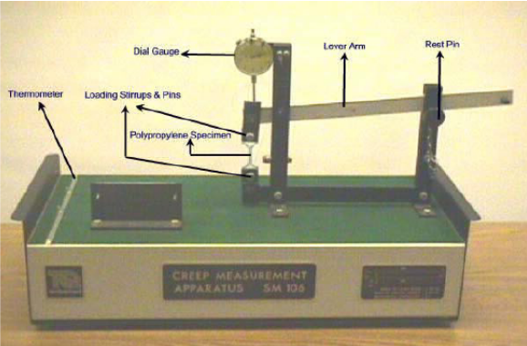

PART – 2
ANIMATION STEPS


PART – 3
VIRTUAL LAB FRAME

